# Assignment 14

# import pandas as pd import

# numpy as np import

# matplotlib.pyplot as plt

# df = pd.read_csv('https://raw.githubusercontent.com/jackiekazil/data-wrangling/master/data/chp3/data-text.csv') df.head(2)

# df1 = pd.read_csv('https://raw.githubusercontent.com/kjam/data-wrangling-pycon/master/data/berlin_weather_oldest.csv') df1.head(2)

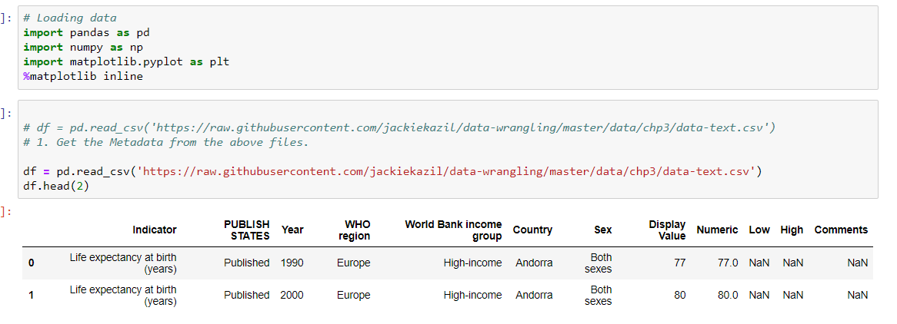

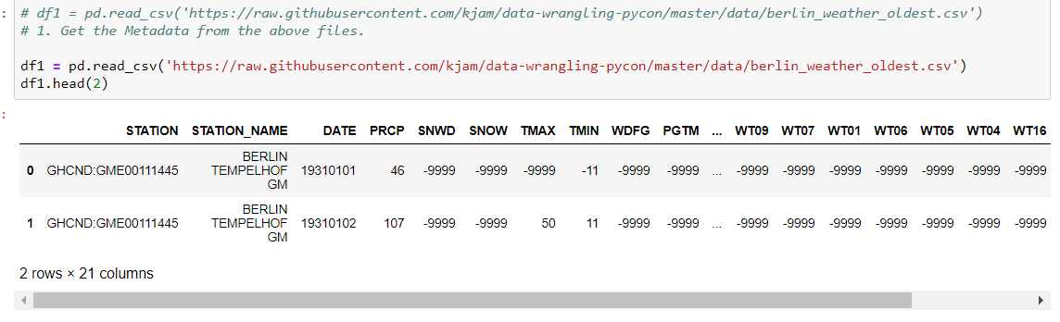

# 1. Get the Metadata from the above files.

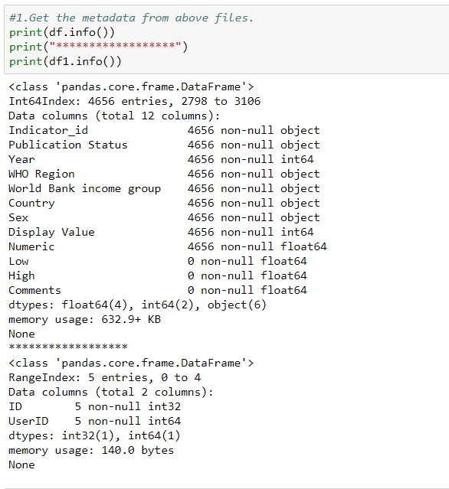

# 2. Get the row names from the above files.

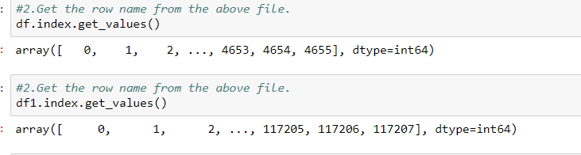

# 3. Change the column name from any of the above file.

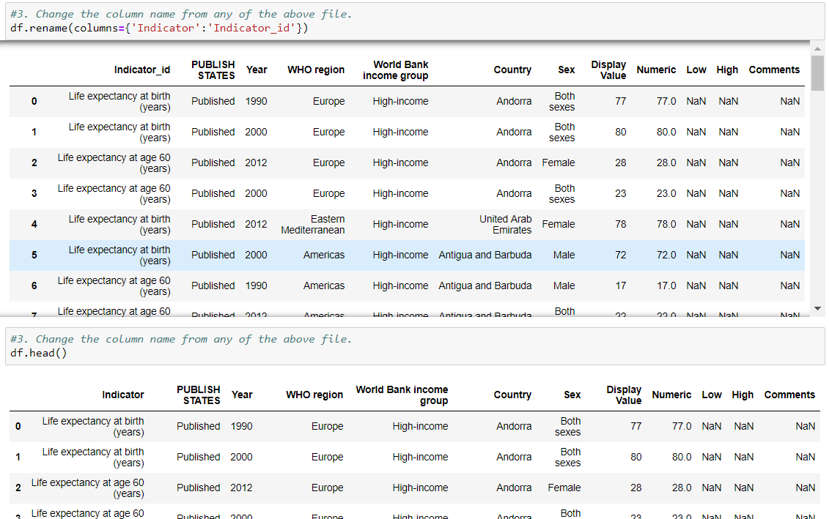

# 4. Change the column name from any of the above file and store the changes made

# permanently.

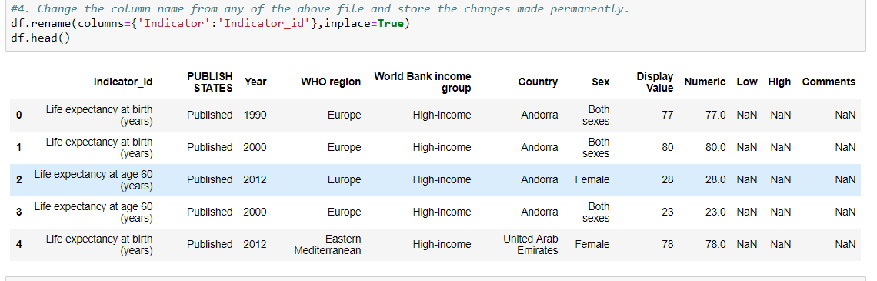

# 5. Change the names of multiple columns.

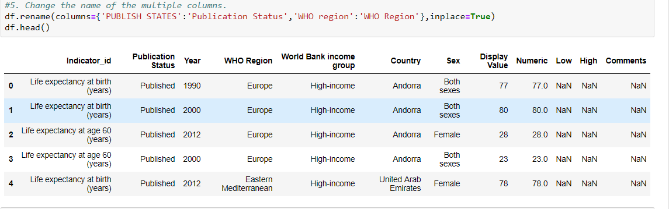

# 6. Arrange values of a particular column in ascending order.

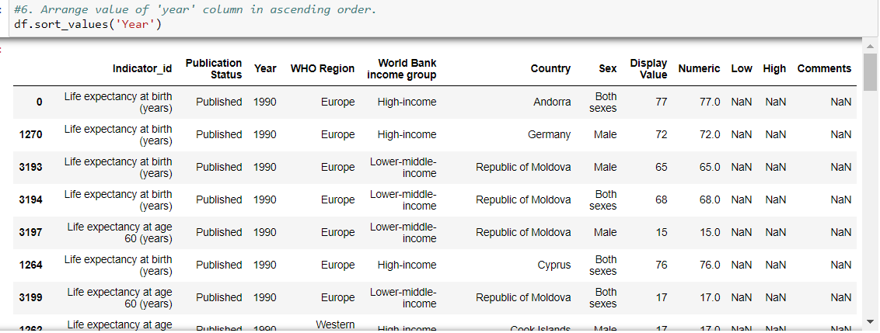

# 7. Arrange multiple column values in ascending order.

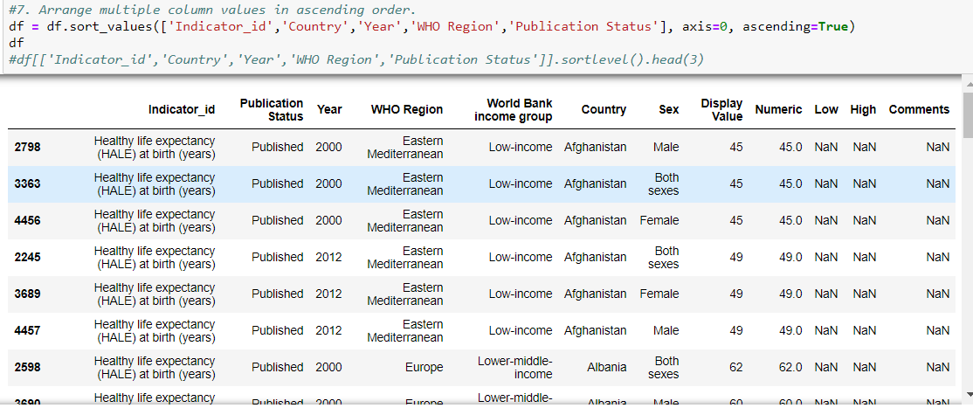

# 8. Make country as the first column of the dataframe. Expected Output:

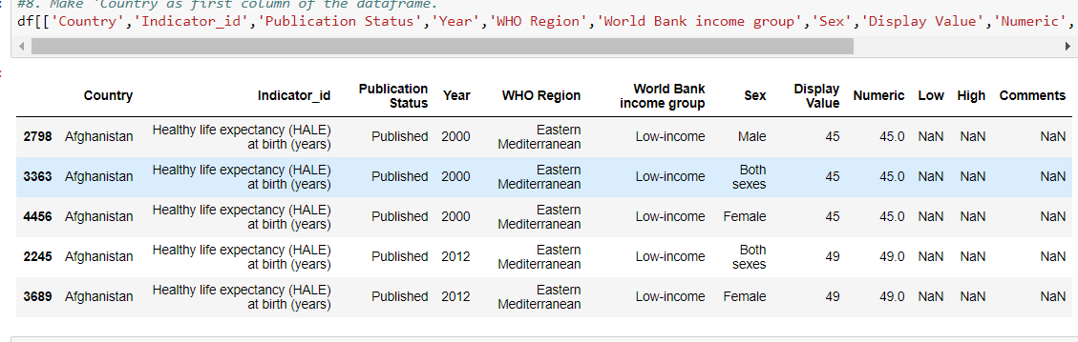

# 9. Get the column array using a variable Expected Output:

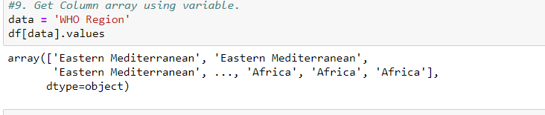

# 10. Get the subset rows 11, 24, 37 Expected Output:

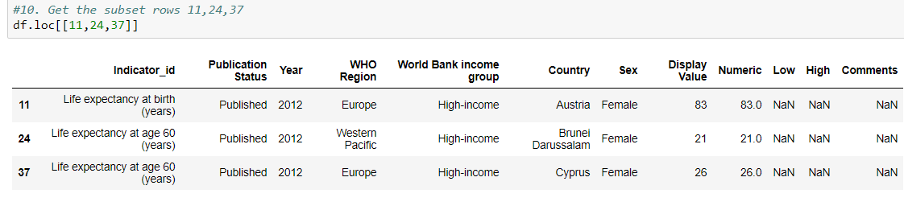

# 11. Get the subset rows excluding 5, 12, 23, and 56 Expected Output:

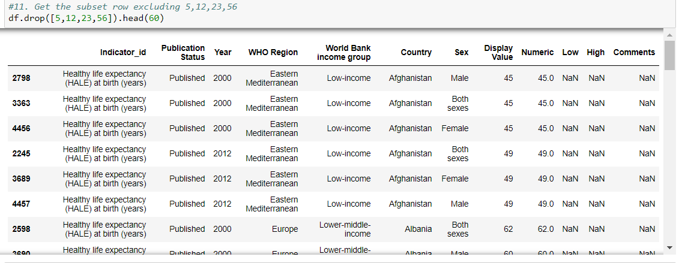

# Load datasets from CSV

# users = pd.read_csv('https://raw.githubusercontent.com/ben519/DataWrangling/master/Data/users.csv' )

# sessions = pd.read_csv('https://raw.githubusercontent.com/ben519/DataWrangling/master/Data/sessions.csv' )

# products = pd.read_csv('https://raw.githubusercontent.com/ben519/DataWrangling/master/Data/products.csv' )

# transactions = pd.read_csv('https://raw.githubusercontent.com/ben519/DataWrangling/master/Data/ transactions.csv')

# users.head() sessions.head() transactions.head()

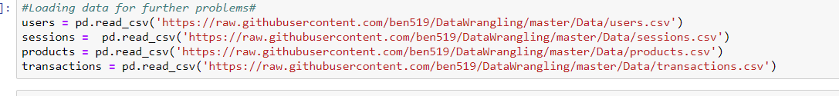

# 12. Join users to transactions, keeping all rows from transactions and only matching rows

# from users (left join)

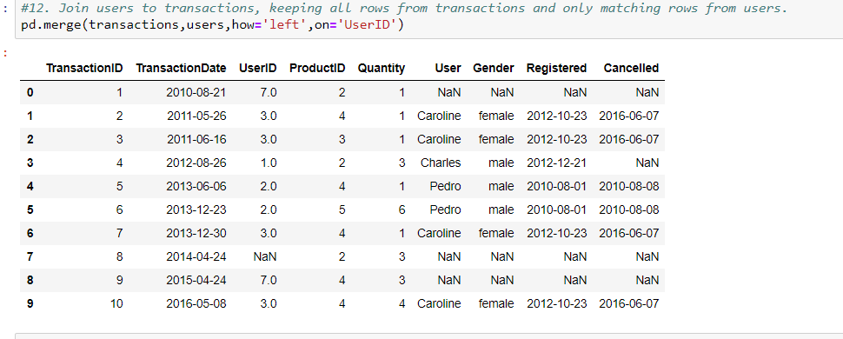

# 13. Which transactions have a UserID not in users?

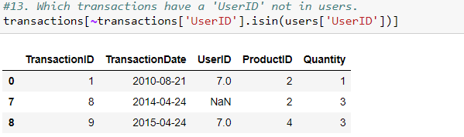

# 14. Join users to transactions, keeping only rows from transactions and users that match

# via UserID (inner join)

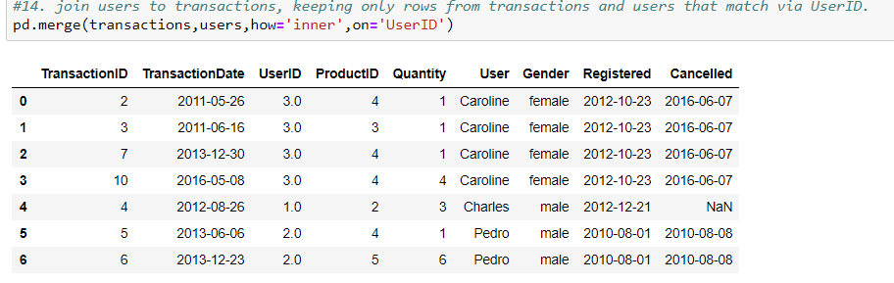

# 15. Join users to transactions, displaying all matching rows AND all non-matching rows

# (full outer join)

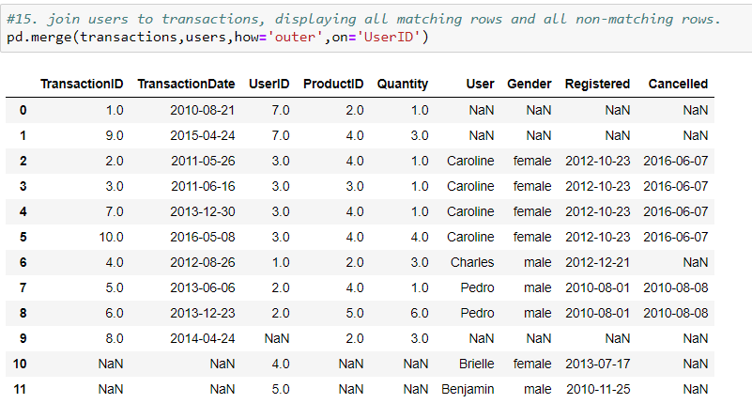

# 16. Determine which sessions occurred on the same day each user registered Expected

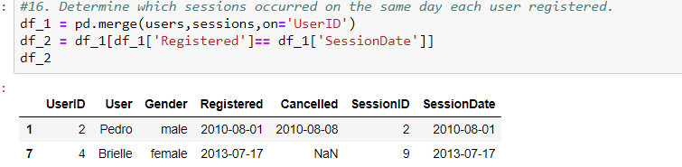

# 17. Build a dataset with every possible (UserID, ProductID) pair (cross join) Expected

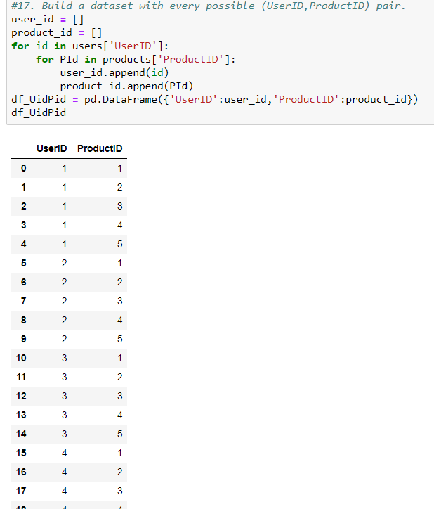

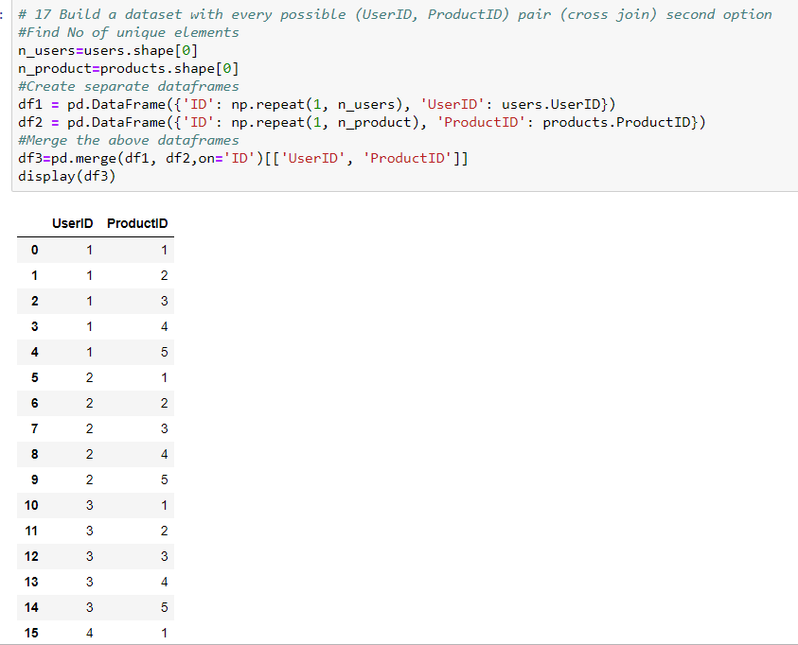

# 18. Determine how much quantity of each product was purchased by each user Expected

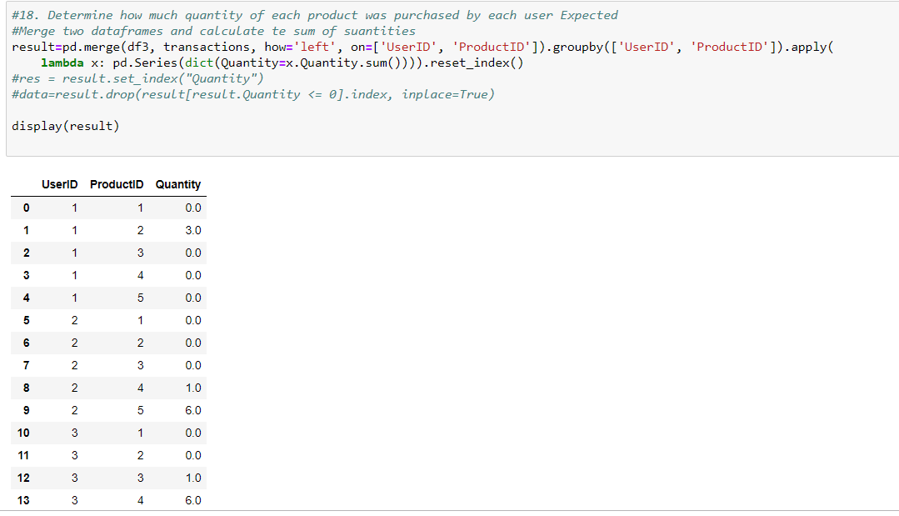

# 19. For each user, get each possible pair of pair transactions (TransactionID1,

# TransacationID2)

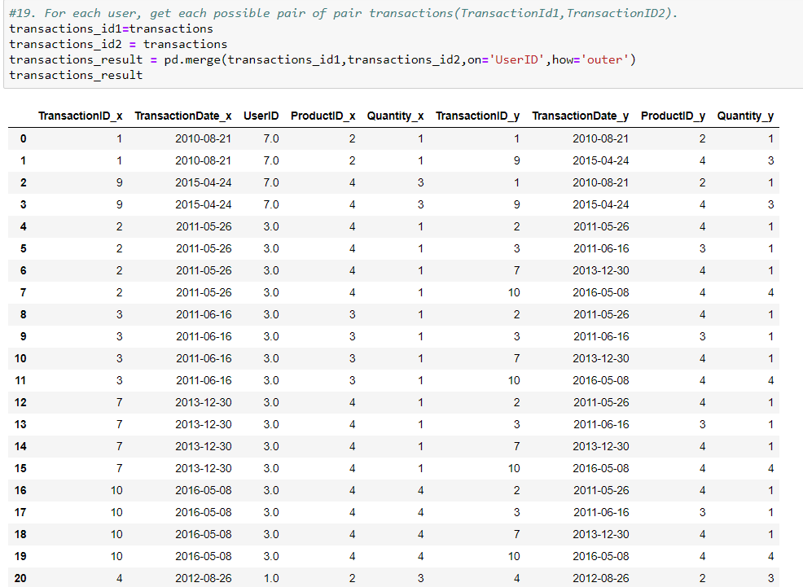

# 20. Join each user to his/her first occuring transaction in the transactions table Expected

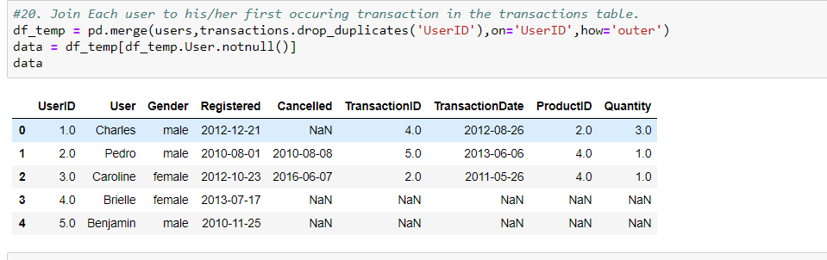

# 21. Test to see if we can drop columns

# Code with Output :

# my_columns = list(data.columns)

my_columns

# ['UserID', 'User', 'Gender', 'Registered', 'Cancelled', 'TransactionID', 'TransactionDate',

# 'ProductID', 'Quantity'] list(data.dropna(thresh=int(data.shape[0] * .9), axis=1).columns)

# #set threshold to drop NAs

# ['UserID', 'User', 'Gender', 'Registered'] missing_info

# = list(data.columns[data.isnull().any()])

#missing_info ['Cancelled', 'TransactionID', 'TransactionDate', 'ProductID', 'Quantity']

# //for col in missing_info:

# num_missing = data[data[col].isnull() == True].shape[0]

#print('number missing for column {}: {}'.format(col, num_missing)) Output: Count of

# missing data

# number missing for column Cancelled: 3 number missing for column TransactionID:

#2 number missing for column TransactionDate: 2 number missing for column ProductID: 2 number missing for column Quantity: 2

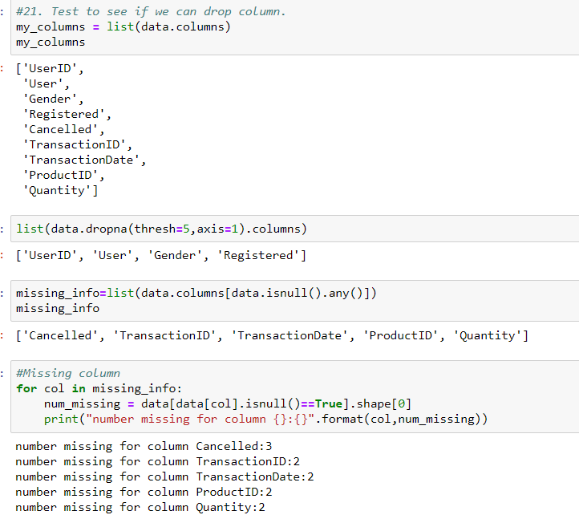

# //for col in missing_info:

# num_missing = data[data[col].isnull() == True].shape[0] print('number missing for

# column {}: {}'.format(col, num_missing)) #count of missing data

# for col in missing_info:

# percent_missing = data[data[col].isnull() == True].shape[0] /

# data.shape[0] print('percent missing for column {}: {}'.format( col,

# percent_missing))

# Output of percentage missing data percent missing for column Cancelled:

#0.6 percent missing for column TransactionID: 0.4 percent missing for column TransactionDate:

#0.4 percent missing for column ProductID: 0.4 percent missing for column Quantity: 0.4

